# Cansolair Solar Heater Efficiency Monitoring Project

Dylan Stone

April 10th, 2017

For Glenn MacLeod, Steve McCarron & James Thomson

# Letter of Intent

Dylan Stone   
3 Maplehurst, Apt. 9   
Dartmouth, NS B2Y 3N7

September 29th, 2016

Glenn MacLeod  
Instructor, Electronic Engineering Technology

Stephen McCarron  
Instructor, Electronic Engineering Technology

Nova Scotia Community College  
80 Mawiomi Place  
Dartmouth, NS B2Y 0A5  
  
Dear Mr. McCarron and Mr. MacLeod,

For my senior project, I will be developing a system that will be able to analyze and display efficiency data from a solar air heater. My project will take data measurements, such as inflow and outflow air temperature, and use the other data such as airflow rate and outside temperature to calculate the efficiency of the unit. I plan on using a microcontroller such as the Raspberry Pi to take measurements and to host a local web server to allow for remote access to the data.

Once I get a Raspberry Pi, I will be making a program to take temperature measurements and log the data. I will slowly be making this program more and more complicated to include more types of data and to display the data in a more convenient way. My goal is to, by the end of the year, have a self-contained device that will work through power outages and Wi-Fi interruptions that can effectively measure the efficiency of the Cansolair solar heater year round and display the data on a local server to be remotely accessed.

Sincerely,

­­­ \_\_\_\_\_\_\_\_\_\_\_\_\_\_\_\_\_\_



Dylan Stone

# Abstract

This report outlines the design and creation of an efficiency monitoring system for the Cansolair solar heater at the NSCC Waterfront Campus. This project was completed with the school’s Applied Research division to gather data on the Cansolair system. This project was completed to learn about the effectiveness of the installed heater, so accurate, informed decisions can be made about the Cansolair heater. This project serves as my Applied Research Project for the Electronic Engineering Technology at the NSCC Waterfront Campus.

# Acknowledgements

Following are the people I would like to thank for their assistance and support throughout various aspects of my project over the last several months.

Faculty

* Glenn Macleod
* Steve MacCarron
* Alain Joseph
* James Thomson
* Dale Jollimore

Table of Contents

[Cansolair Solar Heater Efficiency Monitoring Project 0](#_Toc480362913)

[Letter of Intent 1](#_Toc480362914)

[Abstract 2](#_Toc480362915)

[Acknowledgements 3](#_Toc480362916)

[Introduction 7](#_Toc480362917)

[Cansolair 7](#_Toc480362918)

[Efficiency Monitoring System 7](#_Toc480362919)

[Myself 7](#_Toc480362920)

[Design Process 8](#_Toc480362921)

[Power Calculation 8](#_Toc480362922)

[Energy 8](#_Toc480362923)

[Heat Capacity 8](#_Toc480362924)

[Mass 8](#_Toc480362925)

[Temperature Differential 8](#_Toc480362926)

[Power 8](#_Toc480362927)

[Final Equation 9](#_Toc480362928)

[Temperature Measurements 9](#_Toc480362929)

[Flow Rate 9](#_Toc480362930)

[Basic Program 10](#_Toc480362931)

[Final Program 10](#_Toc480362932)

[Main loop 10](#_Toc480362933)

[flash(pin, state, wait) 10](#_Toc480362934)

[read\_temp\_raw(d\_file) 10](#_Toc480362935)

[read\_temp(d\_file) 10](#_Toc480362936)

[IRup() 10](#_Toc480362937)

[wait(itime, oldtime) 11](#_Toc480362938)

[usave() 11](#_Toc480362939)

[lps(directory) 11](#_Toc480362940)

[Start on boot 11](#_Toc480362941)

[Real-Time Clock 12](#_Toc480362942)

[Physical Design Components 13](#_Toc480362943)

[Cansolair 13](#_Toc480362944)

[Raspberry Pi 13](#_Toc480362945)

[Temperature Sensors 14](#_Toc480362946)

[Circuit Board 14](#_Toc480362947)

[Real-Time Clock 15](#_Toc480362948)

[LEDs and Buttons 15](#_Toc480362949)

[Outtake Vent 16](#_Toc480362950)

[Sensor Connector 17](#_Toc480362951)

[Problems Encountered 18](#_Toc480362952)

[Learning Linux 18](#_Toc480362953)

[Learning Python 18](#_Toc480362954)

[Flow Rate 18](#_Toc480362955)

[Circuit Board 18](#_Toc480362956)

[USB saving 19](#_Toc480362957)

[Energy Calculation Time Differential 19](#_Toc480362958)

[Launching on Boot 19](#_Toc480362959)

[Final Design 20](#_Toc480362960)

[Physical Design 20](#_Toc480362961)

[Spreadsheet Design 22](#_Toc480362962)

[Raw Data 22](#_Toc480362963)

[Daily Data 23](#_Toc480362964)

[Data 23](#_Toc480362965)

[Graphs 24](#_Toc480362966)

[Conclusion 25](#_Toc480362967)

[Appendix A – Code 26](#_Toc480362968)

[Early Temperature Measurement Program 26](#_Toc480362969)

[Main Program 27](#_Toc480362970)

[Reboot Program 33](#_Toc480362971)

[Appendix B – Datasheets and Resources 34](#_Toc480362972)

[Appendix C – Photos 35](#_Toc480362973)

[Appendix D – Cost of Materials 36](#_Toc480362974)

[Appendix E – List of Figures 37](#_Toc480362975)

# Introduction

## Cansolair

The Cansolair is a solar powered heater that is mounted to the side of a building to heat an indoor space. The solar heater uses many recycled pop cans, painted black. These cans are in the enclosure mounted to the building, and as sunlight passes through the glass and hits the pop cans, the air inside the enclosure is heated. All the air inside the Cansolair is kept still by check valves, and when it is hot enough, the fan inside the unit is turned on and air flows through the system heating the inside of the building. When the sun is bright enough, this is enough to leave the fan on constantly; however, when the sun is not bright, this leads to the temperature quickly falling and the fan turning on and off as the temperature rises and falls. The system has an intake inside the building with a control panel to adjust for temperature and is plugged in to power the fan and internal sensors. About 6 feet above the intake is the outflow; it also has a check valve. Ideally, this system will provide heat to a small space year round as long as the sun is shining.

## Efficiency Monitoring System

Because the output of the Cansolair system is as variable as the weather it is unknown exactly how much power the system is outputting. The website, Cansolair.com does outline the output in optimal conditions but it is unknown how representative this is in the real world. A system that could measure if the heater is operating properly, and how much power it is outputting could be very useful. This system will be able to measure and log the power output of the Cansolair solar heater so the efficiency of the heater can be easily viewed.

## Myself

This project was brought up to me by Alain Joseph and James Thomson. I decided to do it because I am interested in efficiency and analyzing data to make more informed decisions. I thought this project would be a good fit for me because large portions of the project are coding focused, and that is something I believe I am good at.

# Design Process

The objective of this project is to measure the power output of the Cansolair solar heater, to do this, I have designed a way to measure the air going through the heater. To calculate the power the heater is generating, I need to use a formula for power. This section will go over the calculation, and the program process to derive an amount of power the system is generating at any given time.

## Power Calculation

### Energy

This is the formula I started with;

$$Energy (kJ)=Heat Capacity\left(\frac{kJ}{kg°C}\right)*Mass \left(kg\right)*Temperature Differential (℃)$$

This formula will allow for energy calculation; however, the variables used are inconvenient for this application so I will adapt the equation for my purposes.

### Heat Capacity

The heat capacity of air is 1.00 for the relevant temperatures for this assignment, therefore using a constant 1 will be sufficient for this project as there will not be any extreme temperatures that would significantly affect the results.

### Mass

The mass of the air can be determined based on the flow rate and the air density. The air density at normal air pressures is 1.125kg/m3, and the flow rate can be represented as a variable in m3/s. Therefore Mass can be rewritten as;

$$Mass Per Second\left(\frac{kg}{s}\right)=Air Density \left(\frac{kg}{m^{3}}\right)*Flow Rate \left(\frac{m^{3}}{s}\right)$$

This formula is mass per second instead of simply mass, as used in the original equation. Therefore, this equation will make the resulting formula calculate power instead of energy (kJ/s instead of kJ).

### Temperature Differential

This will be the primary variable in the equation. It will be determined by subtracting the inflow air temperature to the Cansolair from the outflow air temperature.

### Power

Adjusting the original equation;

$$Power\left(\frac{kJ}{s}\right)= Heat Capacity\left(\frac{kJ}{kg°C}\right)*Air Density \left(\frac{kg}{m^{3}}\right)*Flow Rate \left(\frac{m^{3}}{s}\right)*Temperature Differential (°C)$$

Adding the constants for Heat Capacity and Air Density;

$$Power\left(\frac{kJ}{s}\right)= 1.125\left(\frac{kJ}{m^{3}°C}\right)* Flow Rate \left(\frac{m^{3}}{s}\right)*Temperature Differential (°C)$$

Litres Per Second can represent the flow rate in m3/s by dividing LPS by 1000. Doing this will require dividing the other side of the equation by 1000 as well, leaving (J/s) as the power unit. J/s is commonly represented as Watts.

### Final Equation

$$Power\left(W\right)= 1.125* Flow Rate \left(LPS\right)*Temperature Differential (°C)$$

This final equation leaves two primary variables to calculate power, Temperature Differential, and Flow Rate

## Temperature Measurements

The first step of measuring the efficiency of the Cansolair solar heater is to measure the inflow and outflow air temperature. To measure temperature, I used two One-Wire bus temperature sensors with a Raspberry Pi. To use these DS18B20 temperature sensors, the One-Wire Bus protocol must be enabled under the Raspberry Pi config. This can be accessed by entering “sudo raspi-config” in a terminal. The sensor voltage is connected to the 3.3V GPIO pin on the Raspberry Pi, the ground to the ground pin, and the data to the GPIO-4 pin. The sensors may be connected in parallel to the Raspberry Pi with a 4.7kΩ pull-up resistor between data to 3.3V. Using the program, I can measure each temperature and compare them to get a differential temperature for the formula.

## Flow Rate

The Cansolair solar heater has a fan installed which turns on and off based on the air temperature. This fan is always either on or off; therefore, I do not need to add excessive cost and complexity by including an airflow sensor in my design. I only need to know the air flow rate of the specific installation, and whether the air is flowing at any specific time. To get the flow rate, James Thompson and I used a hot wire flow rate sensor. Using the measurements it took, we calculated the flow rate of the NSCC Cansolair system to be 27 Litres Per Second. The flow rate sensor was acquired late into the project so some data acquired by early prototypes used the Cansolair advertised 47 LPS number. All final per day kWh amounts have, however, been adjusted to the 27 LPS amount.

When a USB drive is inserted into the Raspberry Pi, my program will copy all the data to the USB Drive. One of the copied files is an airspeed text file. This text file is one line of text that is currently “27LPS.” If this text file is adjusted and reinserted into the Raspberry Pi, the program will automatically copy the new airspeed into the program and use that for power calculation. This allows the system to be used in any Cansolair installation by adjusting the flow rate to fit the specific ducts used.

## Basic Program

I started with an [Adafruit guide](https://cdn-learn.adafruit.com/downloads/pdf/adafruits-raspberry-pi-lesson-11-ds18b20-temperature-sensing.pdf) for setting up the temperature sensors I’m using. Using the program from the guide, I modified it and took what is relevant for my project to create a new simple program. I built upon this program over time.

## Final Program

After adding to the simple program over time, I arrived at a final program to be used in the tech showcase.

### Main loop

The beginning of the program is imports for the libraries required and variable definitions for the temperature sensors and miscellaneous variables like time, power, and flow rate. It will then check the airspeed file and get the airflow to be used to calculate power. At the bottom of the program is the loop that will run indefinitely. The main loop starts by setting up the GPIO pins for the LEDs and the buttons. It will then wait an amount of time based on the last time the vent was open. The program will read and save the temperature using the temperature sensors while lighting the measurement LED. The program saves the data to a .csv for the current date and if the day has changed it will save the total energy for the day as well. For the Tech Showcase, I made a section that will display the data on the console. Throughout this loop, the program will periodically check if the vent is open and turn on/off the vent LED. The program will also check for a connected USB flash drive and copy data if there is one available.

### flash(pin, state, wait)

This is a simple function I made to flash an LED. The program needs to be passed a pin number, a 1 or a 0 to determine whether it should flash off or on, and an amount of time in seconds it should flash for. This function will turn the passed GPIO pin to the passed state for the passed time, which is useful at many times in my program.

### read\_temp\_raw(d\_file)

This function is used by the read\_temp function to get the raw data the temperature sensor writes to its device file.

### read\_temp(d\_file)

This function is used in my main loop and it requires a device file address. The function uses read\_temp\_raw to get the raw temperature sensor data and parses the data to get the temperature in Celsius. This function will return this temperature number to the main loop to be saved for later use.

### IRup()

This function checks the state of the IR sensor that determines the vent position, updates the vent LED and returns the vent position. I call this program multiple times in the loop so that the vent LED will quickly update if the vent opens at any point. This function is always used rather than simply checking the state of the vent GPIO pin because this will also update the LED.

### wait(itime, oldtime)

This function is passed a time value and an amount of time to wait. This function will continue to loop until the current time is greater than the passed time value plus the wait time in seconds. It will also stop waiting if the vent is open. While this function is looping, it will check for a connected USB device using the usave() function.

### usave()

This function will check the /media/pi directory on the Raspberry Pi for files. The files in this directory are where USB drives are automatically mounted by the operating system. The function will get the name of every file in the directory and check them one by one. It will check if there is a file with user permissions and if there is, it will save the name and enter an IF statement. If there isn’t, there is not a USB device connected and the function will exit. If there is a file, the program will print the name of the device to the console and light the green LED to signify the USB drive is being accessed. The program will check if there is already a “Data” folder. If there is, it will check for an airspeed file and copy the airspeed from the USB if the data is valid. It will then delete the “Data” folder and copy the data folder from the Raspberry Pi. The operation is complete. This function allows for data to be easily retrieved from the Raspberry Pi by simply inserting a USB drive and allows for airspeed number to be easily changed by adjusting the airspeed number in the data folder.

### lps(directory)

This function will open the file in the passed directory and copy the airspeed number to a global variable to be used to calculate power. It is called when the program starts, and when the usave() function runs. It will return a true if the data is valid and the flow rate has been updated and a false if the data was not valid.

## Start on boot

When the Raspberry Pi is started by connecting it to power it will automatically begin to boot and on the Raspberry Pi 3 a line starting with ‘@’ can be added to “/home/pi/.config/lxsession/LXDE-pi/autostart.” The text following the line will be run when the Raspberry Pi starts, so I added “@lxterminal --title=”Cansolair Efficiency Monitoring System” -e “sudo python /home/pi/Desktop/Programs/PrototypeTech.py”. This will launch a terminal and automatically run the program when the Raspberry Pi boots. I also added a similar line to run a simple program that will look at a GPIO pin that a restart button is plugged into “@sudo python /home/pi/Desktop/Programs/RebootWatch.py.” I also configured the lxterminal window using the file at “/home/pi/.config/lxterminal/lxterminal.conf, and made the terminal launch maximized by adding to the file at “openbox/lxde-pi-rc.xml”. This will allow the system to be easily installed and automatically run if the power goes out or there is some other external problem.

## Real-Time Clock

The Cansolair is in a part of the school that does not have access to Wi-Fi. The Raspberry Pi does not have a real-time clock so when it loses power it loses time; therefore, I have included a real-time clock in my design. To use the real-time clock, I had to disable the hardware clock and tell the Raspberry Pi to use the real-time clock instead. This is a one-time setup and now the Raspberry Pi will automatically sync if connected to the internet, but it will not lose time when disconnected from power.

# Physical Design Components

This section will cover the components of the monitoring system.

## Cansolair

The Cansolair is the solar heater I will be measuring. It is installed at NSCC and has an intake with a small control panel and an 8-inch outtake, where a check valve will be placed. In the picture below, the intake can be seen in the lower right and the outtake as the hole in the center of the wall.

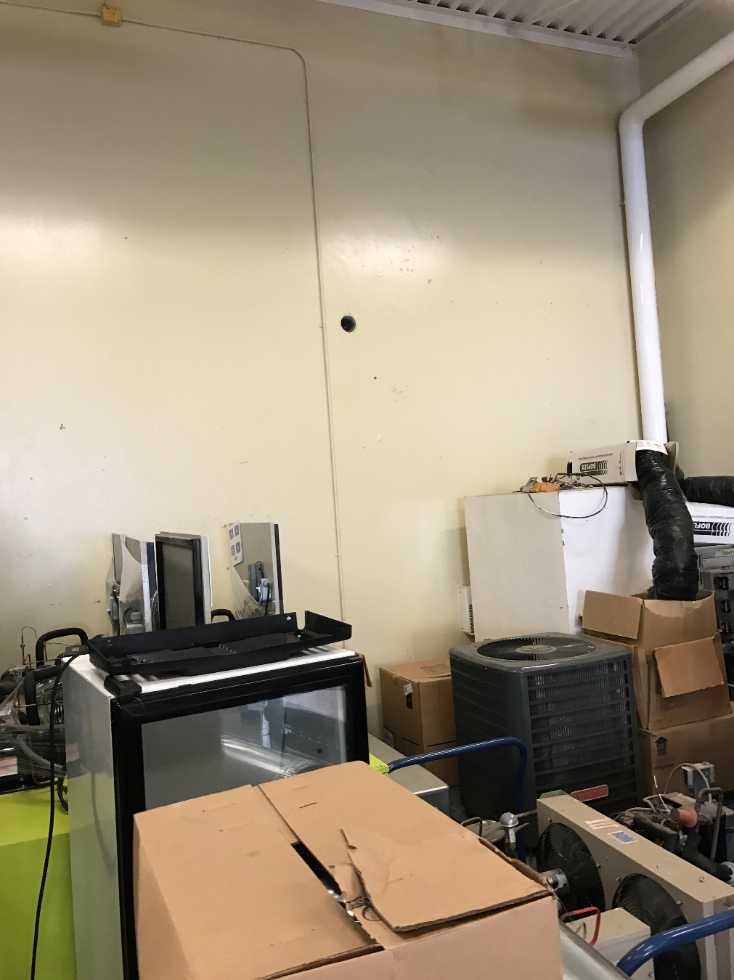

Figure 1- Cansolair Intake and Outtake

## Raspberry Pi

For my project, I decided to use a Raspberry Pi 3, because of its ease to work with, its small size, and its flexibility to do everything required in my project.

[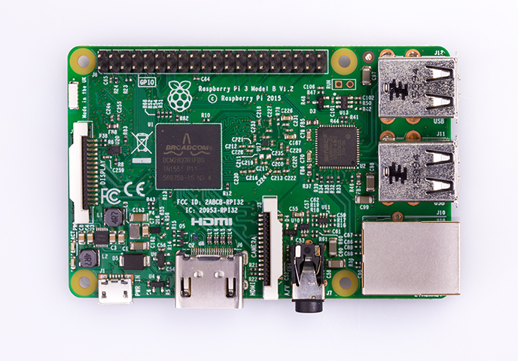](https://www.google.ca/url?sa=i&rct=j&q=&esrc=s&source=images&cd=&cad=rja&uact=8&ved=0ahUKEwj8qdz3h5jTAhXM5CYKHd2QBZgQjRwIBw&url=https://www.raspberrypi.org/products/raspberry-pi-3-model-b/&psig=AFQjCNElWxtjmlvyqXQgIpSSoC0kjVDXeg&ust=1491850928034952)

Figure 2- Raspberry Pi 3

## Temperature Sensors

For my temperature sensors, I decided to use the DS18B20 temperature sensors. These sensors are digital and they work well with the Pi, so it is easy to get accurate measurements into the program. One of these sensors was used for the inflow air and one was used for the outflow air.

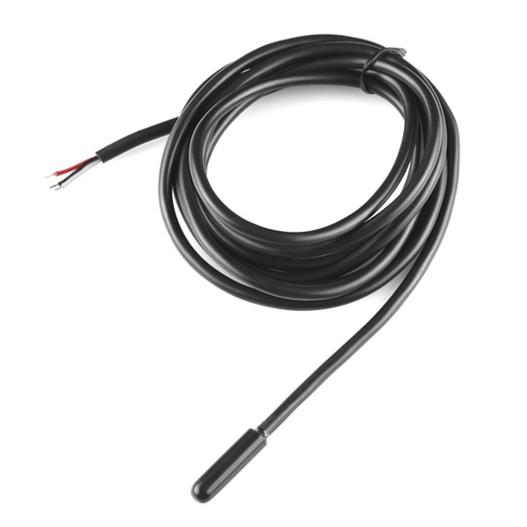

Figure 3 - DS18B20 Digital Temperature Sensor

## Circuit Board

Early into my project, I designed a generic circuit board I could connect to my Raspberry Pi so it could add easy connections to all the pins without making permanent connections to the Raspberry Pi. The board includes headers for the temperature sensors and resistors and LEDs for simple I/O This circuit board was used throughout the design of my project and was included in the final design.

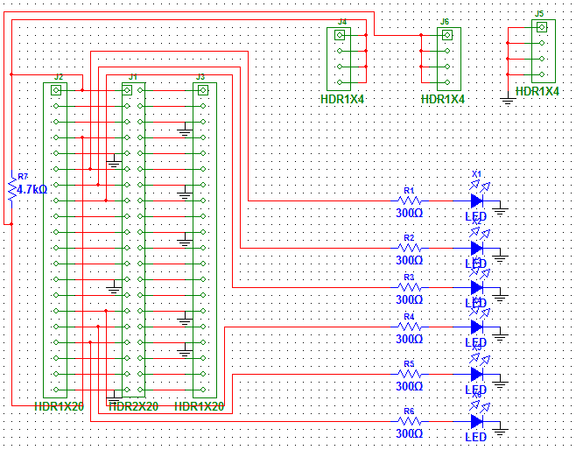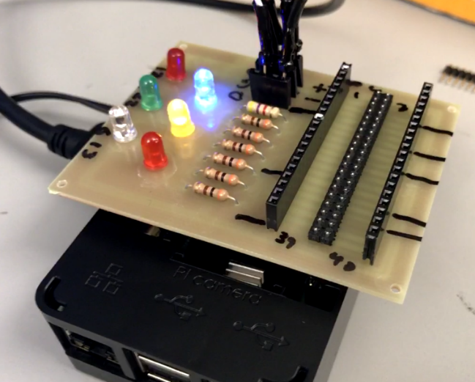

Figure 4 - Circuit Board Schematic and Completed Board

## Real-Time Clock

To keep time in the case of a power loss, I have included the DS1307 RTC. The clock is wired to 5v and ground on the Raspberry Pi and is connected to the I2C pins.

[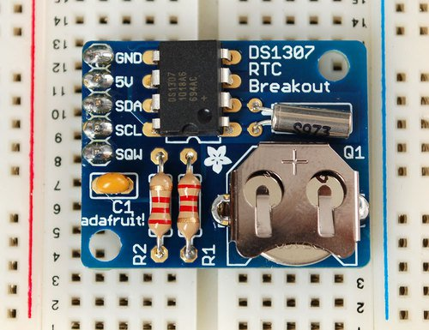](https://www.google.ca/url?sa=i&rct=j&q=&esrc=s&source=images&cd=&cad=rja&uact=8&ved=0ahUKEwjQnKCXjZjTAhXF2SYKHbjdDB8QjRwIBw&url=https://www.adafruit.com/product/264&psig=AFQjCNEHI6Y14hthNIGkCiZ05hl-CQq1MQ&ust=1491852332896810)

Figure 5 - DS1307 Real Time Clock

## LEDs and Buttons

On the front of my final design, I have included two buttons and three LEDs so the operation of the system can be quickly checked at any time. One button will reboot the Raspberry Pi. If there is a problem, the other button will manually take a measurement if the program is on standby. One LED corresponds to the vent position, another to LED lights when measurements are being taken, and the green LED lights when a USB is being written to and will flash when it is complete.

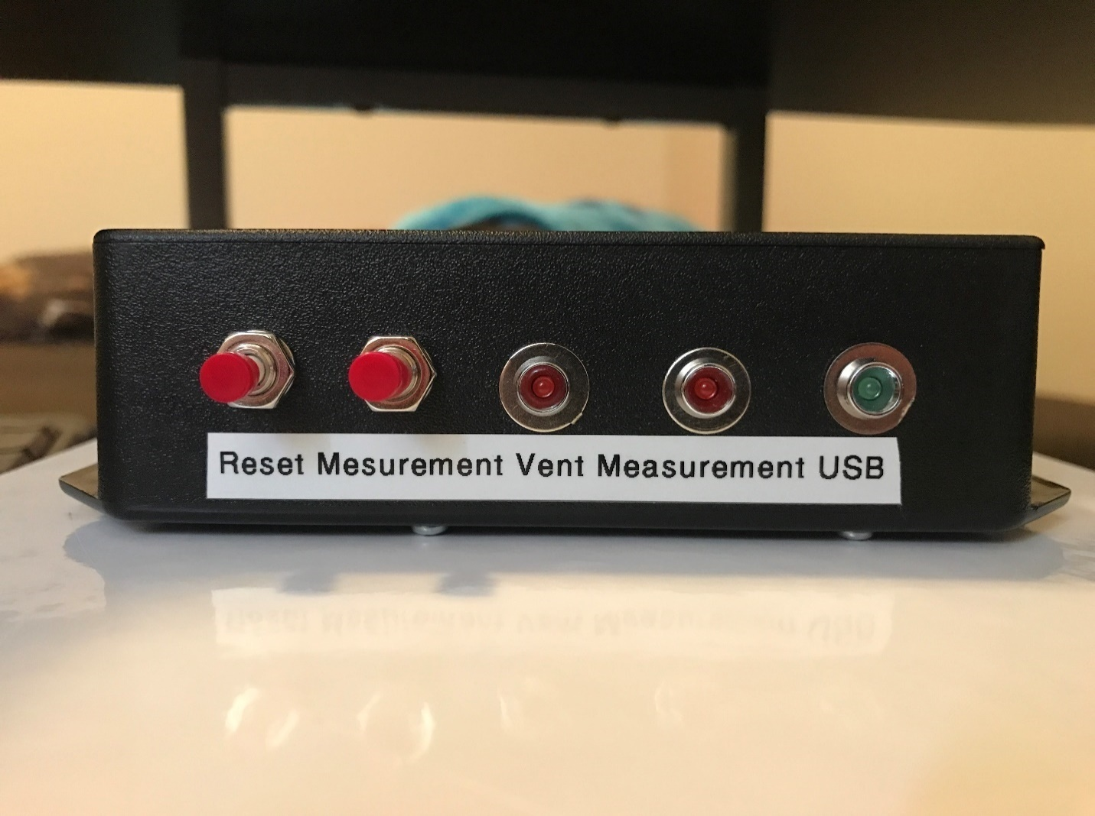

Figure 6 - LEDs and Buttons

## Outtake Vent

I have taken a vent with a flap on it and modified it for use with my project. This 8-inch vent has a flap that opens when the air flows through. I used an infrared sensor by putting the IR LED powered by the Pi on one side of the vent and the receiver on the other. This way the IR sensor will make a wire change states when the vent and opens closes by using a voltage divider. The IR sensor needs voltage, data, and ground. The power is for the LED and the voltage divider and the data will be a high or a low based on the vent position. I can use this in my program as it is connected to the Pi. I also attached one of my temperature sensors to the vent.

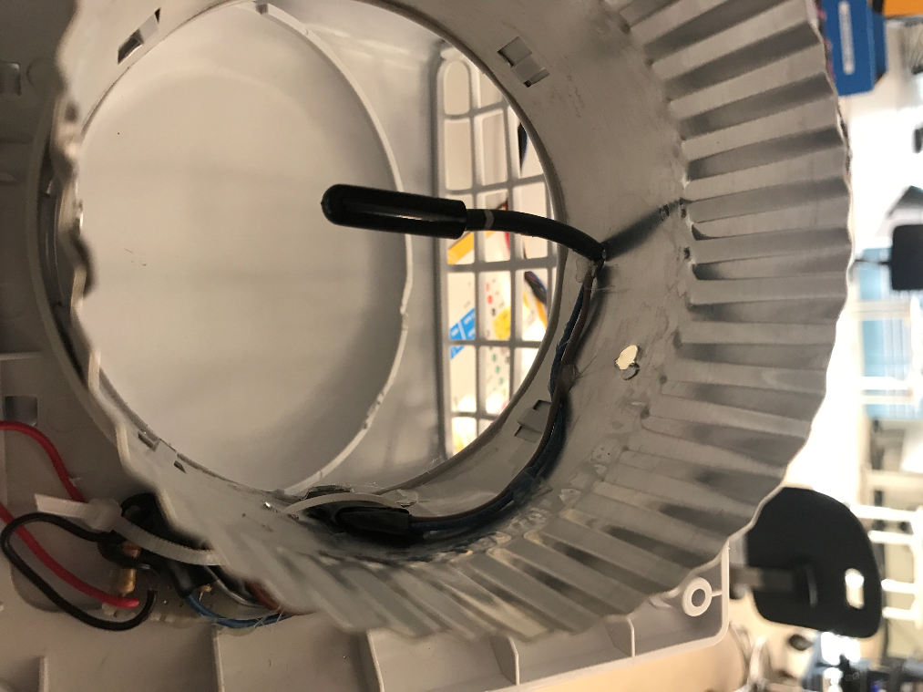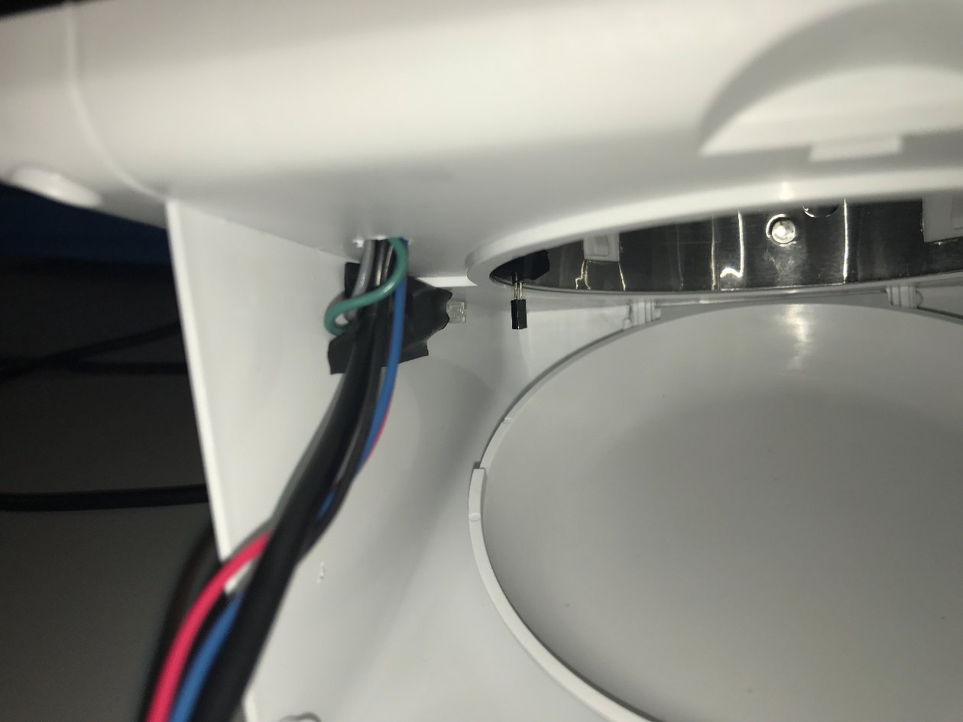

Figure 7 - Outtake vent and IR Sensor

## Sensor Connector

I used the first four pins of a DB-9 connector to connect my sensors to the Raspberry Pi, power, Ground, Temperature Data, and Vent Position High/Low.

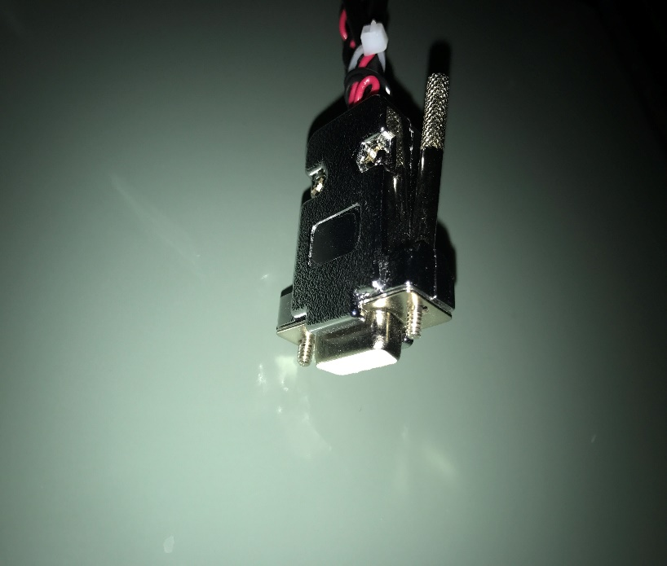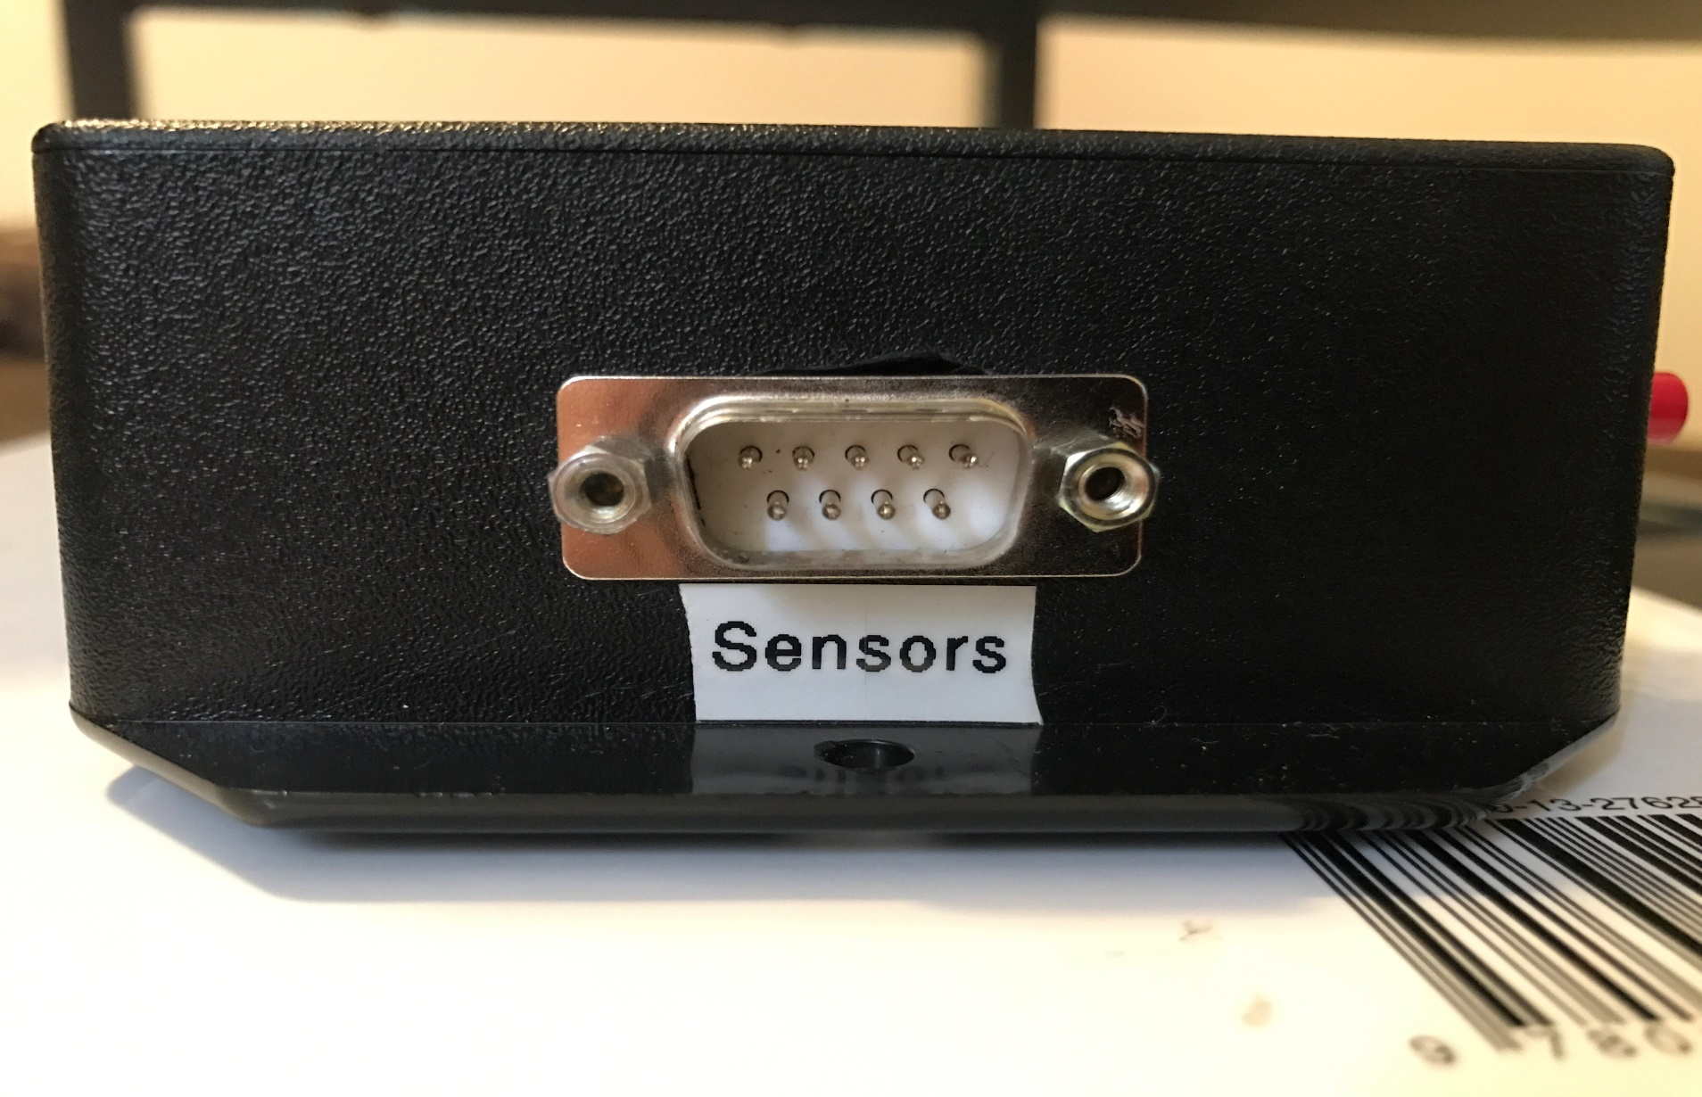

Figure 8 - Sensor Connector

# Problems Encountered

This section will cover the various roadblocks and hurdles I have overcome in the design and creation of this project.

## Learning Linux

When I began this project, I had nearly no experience with a Linux-based operating system like the one the Raspberry Pi runs on. Some of the nuisances of doing things on Linux took some time to get used to, but fortunately, a Google search could fix most problems I faced, with relative ease.

## Learning Python

Prior to starting this project, I had only done coding in the C language, and in LabVIEW. There seemed to be more information for the Raspberry Pi online for Python and the temperature program I started with was in Python. I looked over the temperature program so I understood how it works and I began adding to it as I taught myself how to do it. In the end, it turned out Python was not that different from C, and after a few weeks of adjusting and understanding the differences, I didn’t have many problems with it. The internet is also an extremely good resource whenever I would have a problem.

## Flow Rate

I knew from the beginning I would need to find a way to get the flow rate of the system but accurate sensors are expensive and finding one that could easily connect to the Pi proved to be difficult. I found a 47LPS number on the [Cansolair website](http://cansolair.com) FAQ, so I decided to make the vent with the infrared sensor and use this 47LPS number. This proved to work quite well and later in the project, James Thompson got the flow rate sensor so we could get an accurate measurement.

## Circuit Board

Near the end of 2016, I designed and printed a PCB for my project. Designing and printing the board went relatively well, but when I tried to put headers on the board to attach them to the Raspberry Pi, I realized that they couldn’t reach it while the box was on the Pi. I ended up soldering extra headers to the board to extend the reach and this ended up working quite well.

When I was finalizing my design, I needed to solder my wires directly to my board so they would not come out of the headers. When removing the headers from my board, some copper traces were damaged and my board did not work properly at first. I had to use solder to make sure all the connections were made. This was not an optimal solution but because the milling machine was broken at this time, this was the best solution.

## USB saving

Because I knew there was not internet access at the Cansolair, I decided to program a way to save to a USB drive so the system can remain deployed while data is retrieved from it. I had many problems trying to get this program to work reliably with all USB drives. It didn’t seem to have a problem with the FAT32 file system, but my USB drive is NTFS, which the Raspberry Pi recognizes, but caused many problems. In the end, most problems were solved by adding short delays in between deleting and writing data to the drive. Adding the USB feature ended up being much more complicated than I originally anticipated but in the end, it works quite well, and if it does crash the program, you can use the reset button without any lasting problems.

## Energy Calculation Time Differential

When I first added power calculation, I needed to add a way to track the time between measurements. I made a mistake in the code and the first measurements taken did not calculate energy correctly. Fortunately, the power calculations were right and I found the energy to be nearly exactly 2.5 times smaller in all cases. I scaled up the old data daily measurements by 2.5 times and corrected this in my program.

## Launching on Boot

Originally when I configured my program to automatically start when the Pi is connected to power, it would always launch in the background. It took a lot of time to find a way to start the program from boot while launching a terminal window to display the data if a monitor is connected.

# Final Design

This section will cover the operation and results of the final prototype.

## Physical Design

The final physical design of the Cansolair Efficiency Monitoring System consists of a Raspberry Pi connected to a circuit board, with a real-time clock, a DB-9 connector for the sensors, two buttons, and three LEDs, all inside a box.

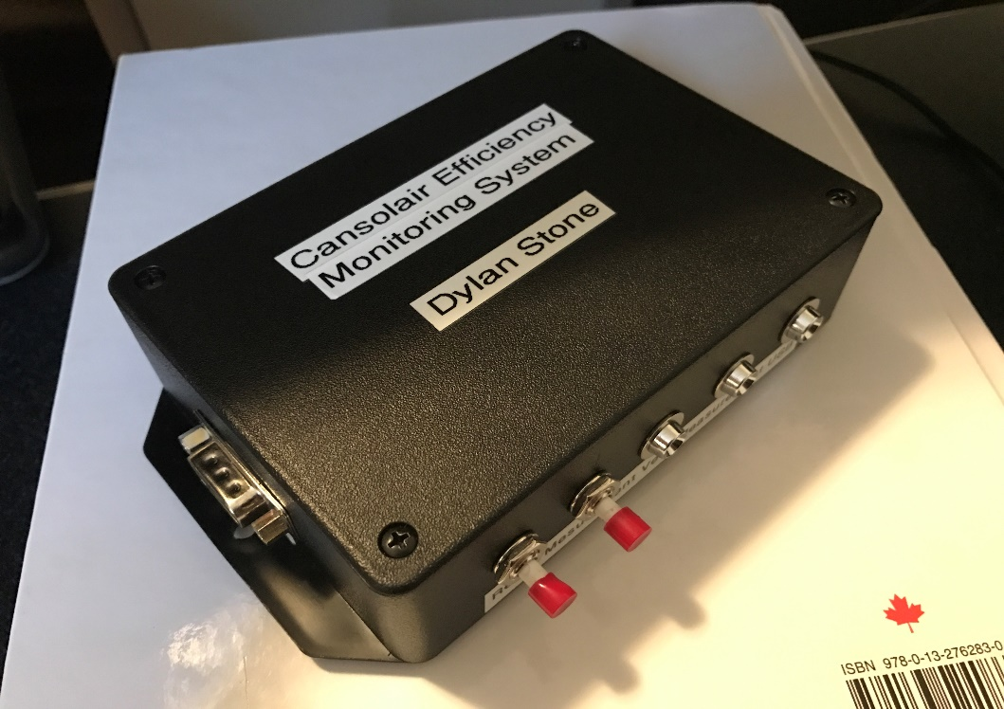

Figure 9 - Final Design, External

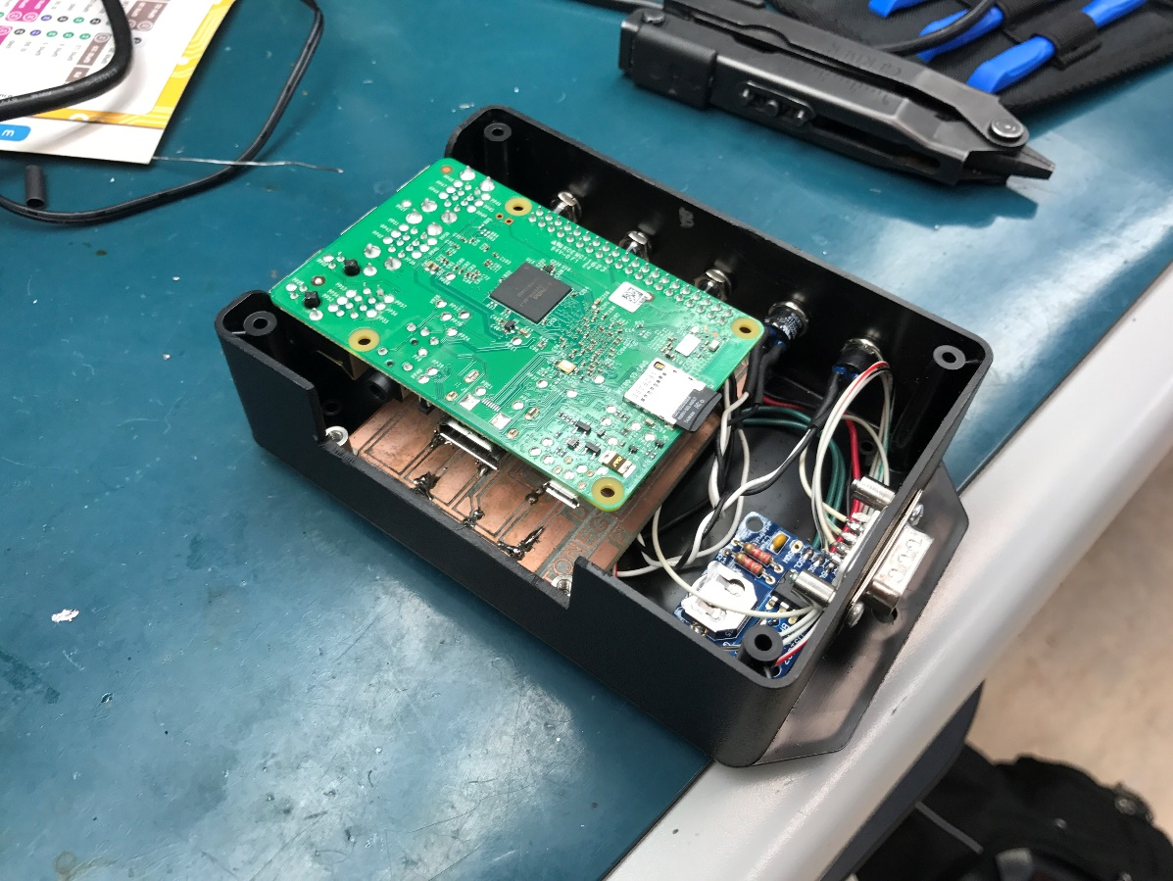

Figure 10 - Final Design, Internal

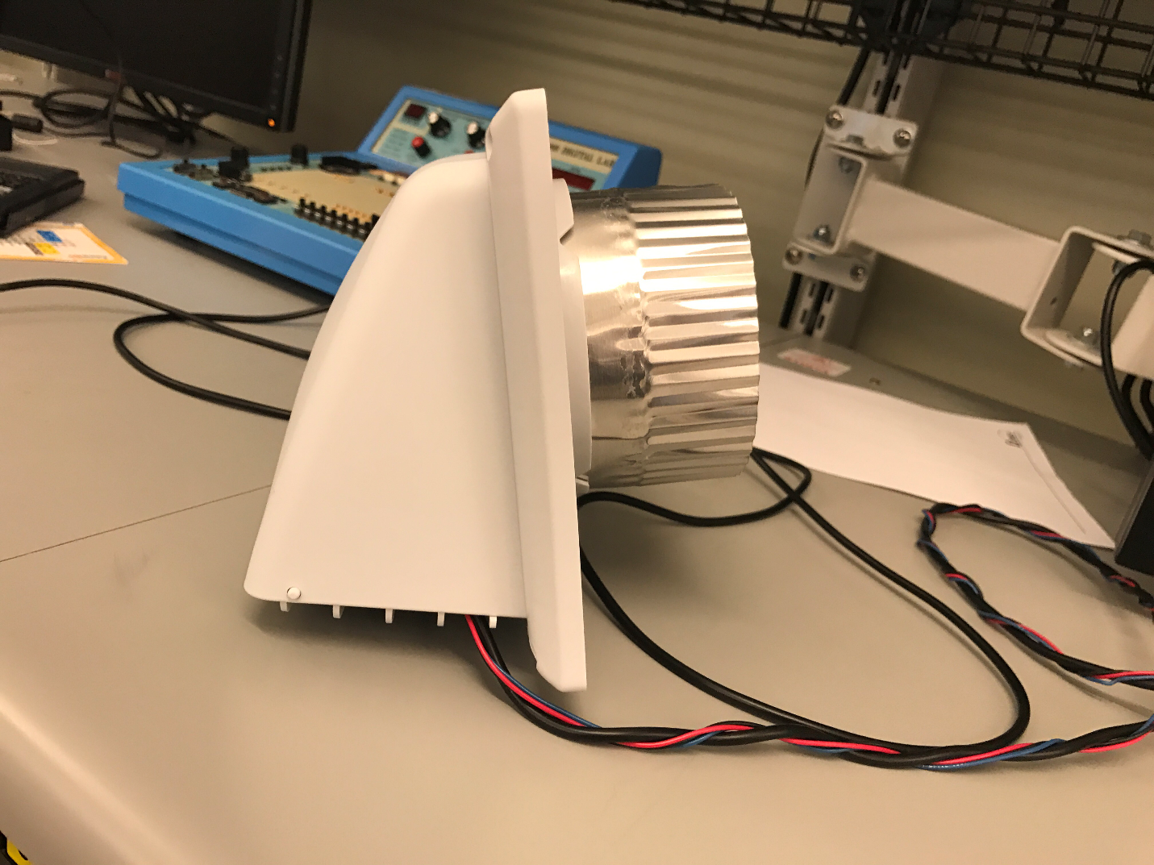

Figure 11 - Outflow Vent

## Spreadsheet Design

As my program takes measurements, it will log the data to spreadsheets. Every day it will start adding to a new spreadsheet, add headers, and it will title the spreadsheet based on the date. The program takes measurements once a minute, but if the outflow vent is open or it has been open recently, it will take measurements more quickly. At the end of every day, it will add to a file that shows the total kWh for each day.

### Raw Data

Below is an example of the beginning of a .csv file for a day:

|  |  |  |  |  |  |  |  |  |
| --- | --- | --- | --- | --- | --- | --- | --- | --- |
| Day of month | Date | Vent Temperature | Ambient Temperature | Difference in Temperature | Vent Open/ Closed | Power (W) | Energy (kWh) | Total Energy (kWh) |
| 26 | 2017-03-26 0:00 | 3.375 | 3.187 | 0.188 | FALSE | 0 | 0 | 0 |
| 26 | 2017-03-26 0:01 | 3.375 | 3.187 | 0.188 | FALSE | 0 | 0 | 0 |
| 26 | 2017-03-26 0:02 | 3.375 | 3.187 | 0.188 | FALSE | 0 | 0 | 0 |
| 26 | 2017-03-26 0:03 | 3.375 | 3.125 | 0.25 | FALSE | 0 | 0 | 0 |
| 26 | 2017-03-26 0:04 | 3.375 | 3.125 | 0.25 | FALSE | 0 | 0 | 0 |
| 26 | 2017-03-26 0:05 | 3.375 | 3.125 | 0.25 | FALSE | 0 | 0 | 0 |
| 26 | 2017-03-26 0:06 | 3.312 | 3.125 | 0.187 | FALSE | 0 | 0 | 0 |

Day of Month – This is simply a number representation of the day of the month. This can be useful if multiple .csv files are combined into one spreadsheet.

Date – This is the time of the measurement, accurate to the second. It is formatted in a way that Excel will automatically understand it.

Vent Temperature – This is the measured temperature exiting the Cansolair.

Ambient Temperature – This is the measured temperature entering the Cansolair.

Difference in Temperature – This is the vent minus the ambient temperature.

Vent Open/Closed – This will be a true if the vent is open and a false if it’s closed.

Power – While the vent is open, this will be the calculated power output.

Energy – As the vent is open, this will accumulate over time based on the power and the time.

Total Energy – When the vent closes, the final energy amount for the cycle will be put in this column. This means Excel can total the entire column to get a total kWh amount.

### Daily Data

Below is an example of the file added to at the end of every day to show the total kWh, per day;

|  |  |
| --- | --- |
| Date | Energy Generated in kWh |
| 2017-03-24 | 2.457248 |
| 2017-03-25 | 1.314694 |
| 2017-03-26 | 6.200412 |
| 2017-03-27 | 0 |
| 2017-03-28 | 0 |

This is extremely useful to get an overview of how the heater has been operating and is, in most cases, all you will need to understand the power output of the Cansolair.

## Data

The monitoring system was left to take measurements for the month of February. The air flow was not known at this time so the raw data is not correct. I have adjusted the final daily kWh amounts to reflect the new air flow number. Below is the kWh generated, per day, in February:

At the bottom is the total kWh for the month, 50 kWh, which translates to $7.56. As this is only one month of data, not much information can be drawn from it so the system will need to be left out for a longer period to get more significant information.

On the next page are graphs showing the March data acquired shortly before Tech Showcase. You can see how variable this system is, but when it does get good sunlight it makes large temperature differentials and generates kilowatts of power. Based on the graphs, it appears the Cansolair is constantly monitoring the internal air temperature so it will only turn on the fan when the system is hot enough. The internal temperature is quite variable but the power output graph very closely resembles a half of a sine wave with anomalies.

|  |  |
| --- | --- |
| Total kWh per day (February) | |
| 1 | 0 |
| 2 | 4.885 |
| 3 | 4.623 |
| 4 | 2.615 |
| 5 | 0.385 |
| 6 | 1.65 |
| 7 | 1.808 |
| 8 | 0 |
| 9 | 1.823 |
| 10 | 0.555 |
| 11 | 0.888 |
| 12 | 4.138 |
| 13 | 0 |
| 14 | 0.238 |
| 15 | 0 |
| 16 | 0 |
| 17 | 0.330 |
| 18 | 1.665 |
| 19 | 0 |
| 20 | 0.150 |
| 21 | 4.478 |
| 22 | 3.71 |
| 23 | 2.775 |
| 24 | 2.433 |
| 25 | 0.580 |
| 26 | 0.948 |
| 27 | 4.900 |
| 28 | 4.608 |
| Total | 50.185 |
|  | $7.56 |

### Graphs

#### C:\Users\Dylan\AppData\Local\Microsoft\Windows\INetCache\Content.Word\week graphs.png

Figure 12 - Week of March 24th Graph

#### C:\Users\Dylan\AppData\Local\Microsoft\Windows\INetCache\Content.Word\day3 graphs.png

Figure 13 - March 26th Graph

# Conclusion

This project proved to be quite successful. I began with the goal of designing a system that could accurately and reliably measure the power output of the Cansolair system, and I believe I have done that. If the February data is representative of the Cansolair power generation for the colder months, it is, in fact, generating a significant amount of power. I was not expecting to see such promising results from black pop cans mounted to the side of a building, but it is generating large temperature differentials on some days and generating a significant amount of heat. The problem is, it is still an expensive system. Based on the information I have gathered the $2000+ it costs to have a Cansolair installed makes it a hard sell, considering the decades it would have to work flawlessly to make that money back. Because of the Cansolair’s variability with weather and its limitation to producing heat in the day time, it cannot replace a typical heating system. The Cansolair will have a hard time competing with electric heating. However, like many environmentally friendly alternatives, it isn’t only about whether it can be more efficient than fossil fuels, it’s about if it can be a viable option to help limit our reliance on fossil fuels, and the Cansolair seems to be a step in the right direction.

# Appendix A – Code

## Early Temperature Measurement Program

Page 14 of [this Adafruit guide](https://cdn-learn.adafruit.com/downloads/pdf/adafruits-raspberry-pi-lesson-11-ds18b20-temperature-sensing.pdf)

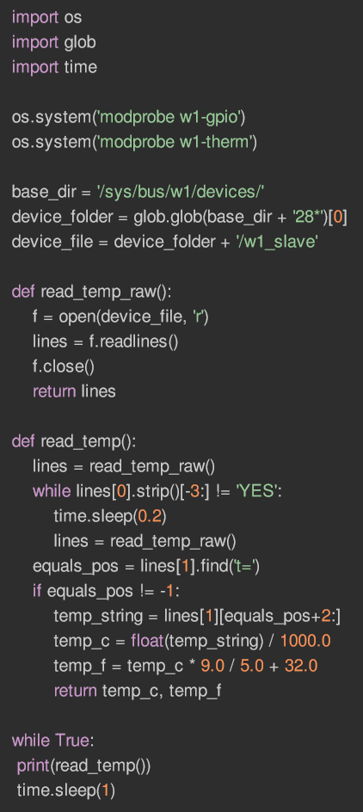

## Main Program





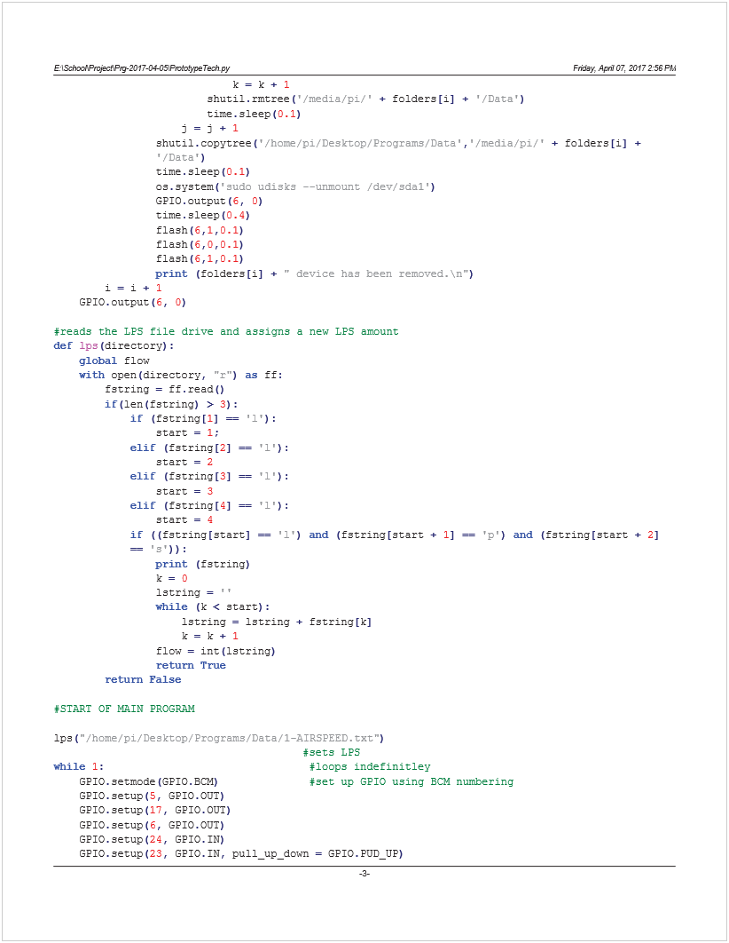

![Machine generated alternative text:
E:\School\Project\Prg-2017-04-05\PrototypeTech.py
Friday, April 07, 2017 2:56 P
M
usave
()
#tries to copy data to usb
if
IRup
():
#checks the vent position and waits a diferent amount
otime
=
time
.
time
()
#of time depending on the last time the vent was open
wait
(
1
,
oldtime
)
#if the vent is open now
elif
((
time
.
time
()-
otime
)<=
300
):
wait
(
10
,
oldtime
)
#if the vent was last open under 300 secs ago
elif
((
time
.
time
()-
otime
)<=
900
):
wait
(
30
,
oldtime
)
#if the vent was last open under 900 secs ago
else
:
wait
(
60
,
oldtime
)
#else
oldtime
=
time
.
time
()
#saves the measurement start time 
GPIO
.
output
(
5
,
1
)
#turns on the measurement light
temp1
=
read_temp
(
device_file1
)
#reads the first temperature
IRup
()
flash
(
5
,
0
,
0.1
)
#flashes LED and updates vent
IRup
()
temp2
=
read_temp
(
device_file2
)
#reads the second temperature
IRup
()
flash
(
5
,
0
,
0.1
)
#flashes LED and updates vent
IRup
()
#creates date string
date2
=
'/home/pi/Desktop/Programs/Data/'
+
str
((
time
.
localtime
()).
tm_year
)+
"-"
+
str
((
time
.
localtime
()).
tm_mon
)+
"-"
+
str
((
time
.
localtime
()).
tm_mday
)+
'.csv'
with
open
(
date2
,
'a'
)
as
f
:
#opens file to save data
if
(
f
.
tell
()==
0
):
#adds headers if it's a new file
f
.
write
(
"Day of month,Date,Vent Temperature,Ambient Temperature,Difference in 
Temperature,Vent Open/Closed,Power(W),Energy(kWh),Total Energy(kWh)\n"
)
timedata
=
str
(
time
.
ctime
()).
split
(
" "
)
if
(
timedata
[
2
]==
''
):
#splits up date and time to reformat it
timedata
[
2
]=
timedata
[
3
]
timedata
[
3
]=
timedata
[
4
]
timedata
[
4
]=
timedata
[
5
]
#reformats date string
savetime
=
"\""
+
timedata
[
1
]+
" "
+
timedata
[
2
]+
", "
+
timedata
[
4
]+
" "
+
timedata
[
3
]+
"\""
tempdata
=
str
((
time
.
localtime
()).
tm_mday
)+
","
+
savetime
+
','
+
str
(
round
(
temp1
,
3
))+
','
+
str
(
round
(
temp2
,
3
))+
','
+
str
(
round
(
abs
(
temp1
-
temp2
),
3
))+
','
+
str
(
IRup
())
if
IRup
():
#calculates power if the vent is open
if
(
totalen
==
0
):
oldtime2
=
time
.
time
()-
2.7
power
=
1.125
*
flow
*(
temp1
-
temp2
)
energy
=(
power
*(
time
.
time
()-
oldtime2
))/
3600
/
1000
totalen
=
totalen
+
energy
tempdata
=
tempdata
+
','
+
str
(
round
(
power
,
3
))+
','
+
str
(
round
(
totalen
,
3
))+
",0"
else
:
#adds zeroes if the vent is closed
energy
=
0
power
=
0
if
(
not
(
totalen
==
0
)):
tempdata
=
tempdata
+
",0,0,"
+
str
(
round
(
totalen
,
3
))
dayen
=
dayen
+
totalen
#adds the total energy to the end
totalen
=
0
else
:
tempdata
=
tempdata
+
",0,0,0"
print
(
str
(
round
(
time
.
time
()-
oldtime2
,
2
))+
" seconds"
)
-4-
]()

![Machine generated alternative text:
E:\School\Project\Prg-2017-04-05\PrototypeTech.py
Friday, April 07, 2017 2:56 P
M
oldtime2
=
time
.
time
()
#saves the last time power was calculated
if
(
startup
):
#adds a line to show the start of the program
tempdata
=
tempdata
+
",Program has started\n"
else
:
#or adds the line terminator
tempdata
=
tempdata
+
'\n'
f
.
write
(
tempdata
)
#saves the data
if
((
time
.
localtime
()).
tm_mday
!=
oldday
.
tm_mday
):
with
open
(
'/home/pi/Desktop/Programs/Data/2-DAILYDATA.csv'
,
'a'
)
as
f
:
f
.
write
(
str
(
oldday
.
tm_year
)+
'/'
+
str
(
oldday
.
tm_mon
)+
'/'
+
str
(
oldday
.
tm_mday
)
+
','
+
str
(
round
(
dayen
,
6
))+
'\n'
)
oldday
=
time
.
localtime
()
#if the day has changed the program will save total kWh
dayen
=
0
#reset total
os
.
system
(
"clear"
)
print
(
savetime
.
split
(
"\""
)[
1
]+
'\n'
)
print
(
str
(
flow
)+
"lps"
)
print
(
"\nAmbient Temperature"
)
print
(
"Degrees C  15  16  17  18  19  20  21  22  23  24  25  26  27  28  29  30  31  32
33  34  35  36  37  38  39  40  41  42  43  44  45  46  47  48  49  50"
)
print
(
"           |   |   |   |   |   |   |   |   |   |   |   |   |   |   |   |   |   |
|   |   |   |   |   |   |   |   |   |   |   |   |   |   |   |   |   |"
)
temp2a
=(
str
(
format
(
temp2
,
'.3f'
)))+
"  -  |"
temp2
=
temp2
-
0.5
while
(
temp2
>=
15
):
temp2a
=
temp2a
+
"="
temp2
=
temp2
-
0.25
temp2a
=
temp2a
+
"|"
print
(
temp2a
)
print
(
"\nVent Temperature"
)
print
(
"Degrees C  15  16  17  18  19  20  21  22  23  24  25  26  27  28  29  30  31  32
33  34  35  36  37  38  39  40  41  42  43  44  45  46  47  48  49  50"
)
print
(
"           |   |   |   |   |   |   |   |   |   |   |   |   |   |   |   |   |   |
|   |   |   |   |   |   |   |   |   |   |   |   |   |   |   |   |   |"
)
temp1a
=(
str
(
format
(
temp1
,
'.3f'
)))+
"  -  |"
temp1
=
temp1
-
0.5
while
(
temp1
>=
15
):
temp1a
=
temp1a
+
"="
temp1
=
temp1
-
0.25
temp1a
=
temp1a
+
"|"
print
(
temp1a
)
if
(
IRup
()):
print
(
"\nPower"
)
print
(
"Power kW   0.0     0.1     0.2     0.3     0.4     0.5     0.6     0.7
0.8     0.9     1.0     1.1     1.2     1.3     1.4     1.5     1.6     1.7"
)
print
(
"           |       |       |       |       |       |       |       |
|       |       |       |       |       |       |       |       |       |"
)
powera
=(
str
(
format
(
power
/
1000
,
'.4f'
)))+
"  -  |"
power
=
power
-
25
while
(
power
>=
0
):
powera
=
powera
+
"="
power
=
power
-
12.5
powera
=
powera
+
"|"
-5-
](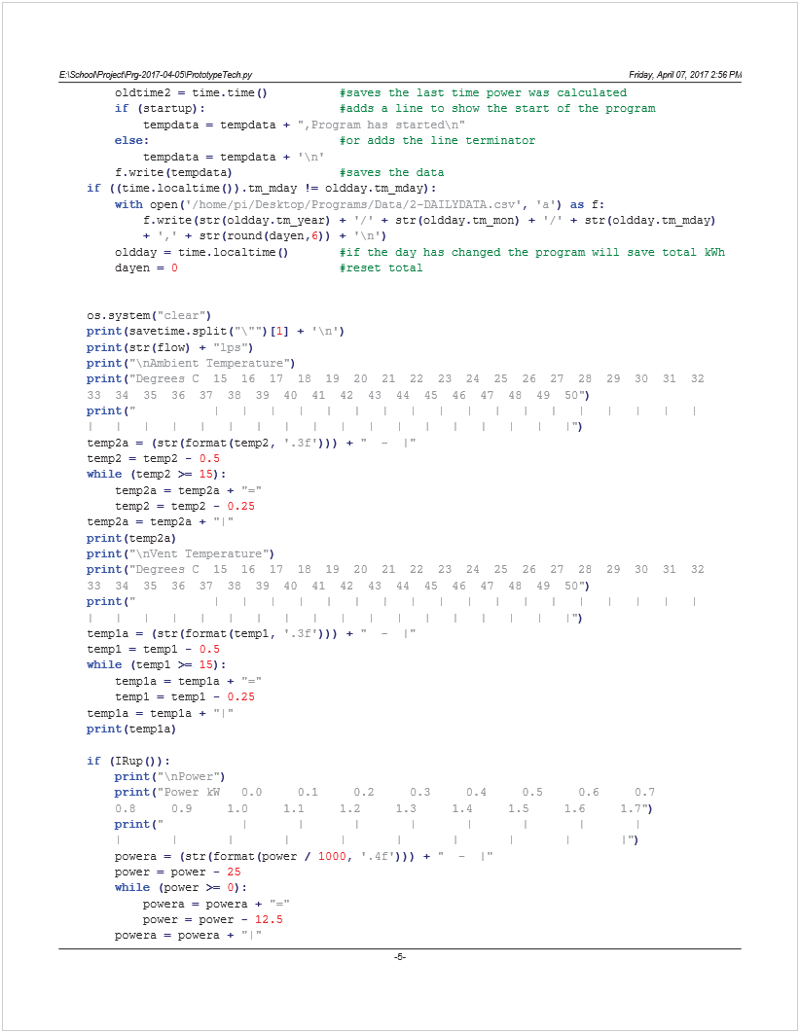)

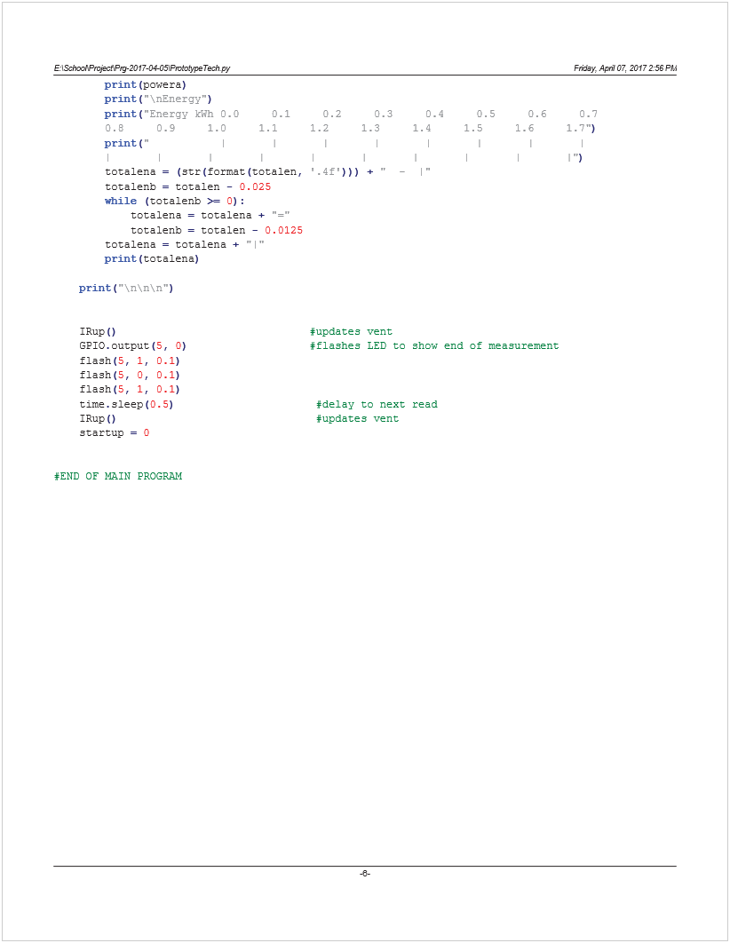

## Reboot Program

This program is launched in the background when the Pi starts, the program waits for the reboot button to be pressed and sends a reboot command if it is.

1. import os
2. import glob
3. import time
4. import RPi.GPIO as GPIO
5. import sys
6. import shutil
7. GPIO.setwarnings(False)

8

1. GPIO.setmode(GPIO.BCM)
2. GPIO.setup(25, GPIO.IN, pull\_up\_down = GPIO.PUD\_UP)
3. while(GPIO.input(25)):
4. time.sleep(0.05)
5. GPIO.setup(17, GPIO.OUT)
6. GPIO.setup(6, GPIO.OUT)
7. GPIO.setup(5, GPIO.OUT)
8. GPIO.output(17, 0)
9. GPIO.output(6, 0)
10. time.sleep(0.15)
11. GPIO.output(17, 1)
12. GPIO.output(6, 1)
13. time.sleep(0.25)
14. GPIO.output(17, 0)
15. GPIO.output(6, 0)
16. time.sleep(0.15)
17. GPIO.output(17, 1)
18. GPIO.output(6, 1)
19. time.sleep(0.25)
20. GPIO.output(17, 0)
21. GPIO.output(6, 0)
22. GPIO.output(5, 1)
23. os.system("sudo reboot")

# Appendix B – Datasheets and Resources

Raspberry Pi - <https://www.raspberrypi.org/documentation/hardware/computemodule/RPI-CM-DATASHEET-V1_0.pdf>

Temperature Sensor - <https://cdn.sparkfun.com/datasheets/Sensors/Temp/DS18B20.pdf>

Real Time Clock - <https://datasheets.maximintegrated.com/en/ds/DS1307.pdf>

Temperature Sensor Guide - <https://cdn-learn.adafruit.com/downloads/pdf/adafruits-raspberry-pi-lesson-11-ds18b20-temperature-sensing.pdf>

Real Time Clock Guide - <https://learn.adafruit.com/adding-a-real-time-clock-to-raspberry-pi/overview>

# Appendix C – Photos

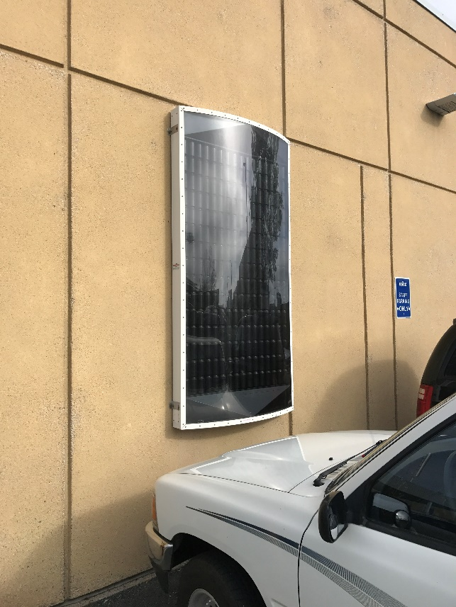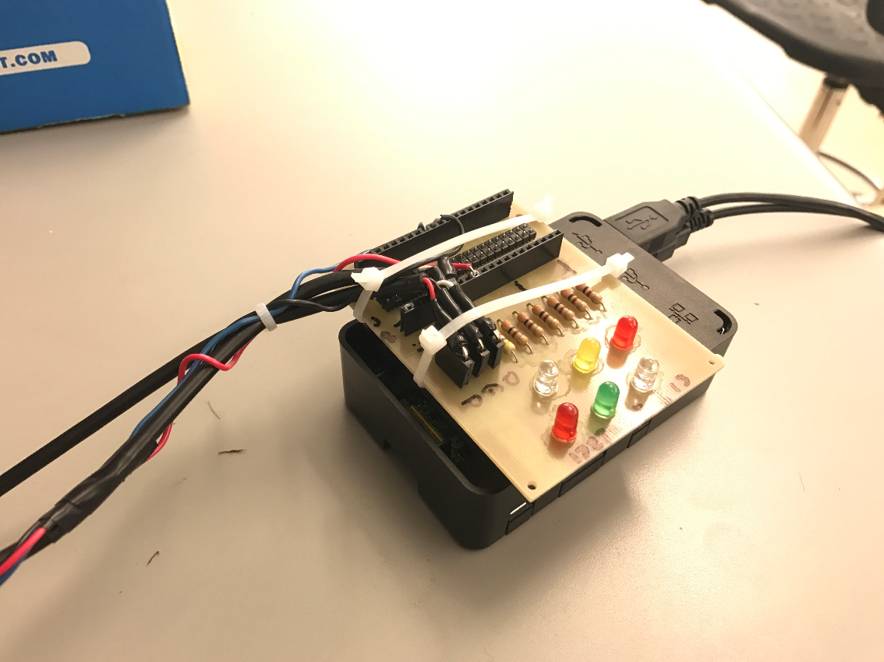

Figure 14 - Cansolair

Figure 15 – First Prototype

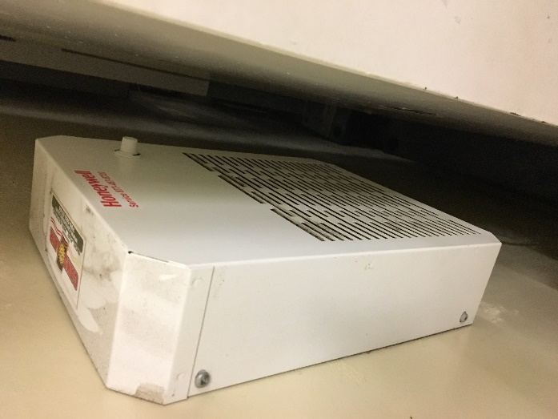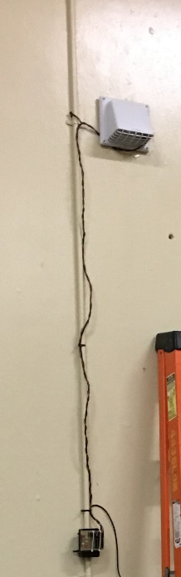 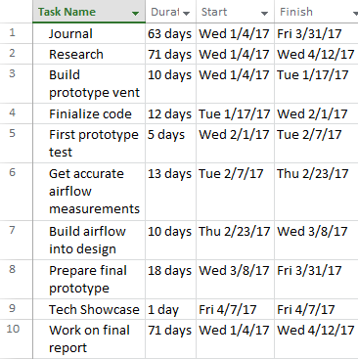

Figure 16- Cansolair Intake/Control Panel

Figure 17 - Installed Prototype

Figure 18 – Gantt Chart

# Appendix D – Cost of Materials

Raspberry Pi 3 – $62.91 - [https://www.digikey.ca/product-detail/en/raspberry-pi/RASPBERRY-PI-3/1690-1000-ND/6152799](https://www.digikey.ca/product-detail/en/raspberry-pi/RASPBERRY-PI-3/1690-1000-ND/6152799%20)

DS18B20 x2 – $15.24 x2 - <https://www.digikey.ca/product-detail/en/sparkfun-electronics/SEN-11050/1568-1228-ND/5721423>

DS1307 - $11.43 - [https://www.digikey.ca/product-detail/en/adafruit-industries-llc/264/1528-1442-ND/5761210](https://www.digikey.ca/product-detail/en/adafruit-industries-llc/264/1528-1442-ND/5761210%20)

Vent – $32.63 - [https://www.homedepot.ca/en/home/p.wall-cap.1000107077.html](https://www.homedepot.ca/en/home/p.wall-cap.1000107077.html%20)

Total - $122.21

# Appendix E – List of Figures

[Figure 1- Cansolair Intake and Outtake 13](#_Toc480362888)

[Figure 2- Raspberry Pi 3 13](#_Toc480362889)

[Figure 3 - DS18B20 Digital Temperature Sensor 14](#_Toc480362890)

[Figure 4 - Circuit Board Schematic and Completed Board 14](#_Toc480362891)

[Figure 5 - DS1307 Real Time Clock 15](#_Toc480362892)

[Figure 6 - LEDs and Buttons 15](#_Toc480362893)

[Figure 7 - Outtake vent and IR Sensor 16](#_Toc480362894)

[Figure 8 - Sensor Connector 17](#_Toc480362895)

[Figure 9 - Final Design, External 20](#_Toc480362896)

[Figure 10 - Final Design, Internal 20](#_Toc480362897)

[Figure 11 - Outflow Vent 21](#_Toc480362898)

[Figure 12 - Week of March 24th Graph 24](#_Toc480362899)

[Figure 13 - March 26th Graph 24](#_Toc480362900)

[Figure 14 - Cansolair 35](#_Toc480362901)

[Figure 15 – First Prototype 35](#_Toc480362902)

[Figure 16- Cansolair Intake/Control Panel 35](#_Toc480362903)

[Figure 17 - Installed Prototype 35](#_Toc480362904)

[Figure 18 – Gantt Chart 35](#_Toc480362905)